How to set up a password for your Mac in 4 easy steps

1. Go to the Apple icon in the top left corner of the your screen

2. System preferences (4th row down) click Users & Group

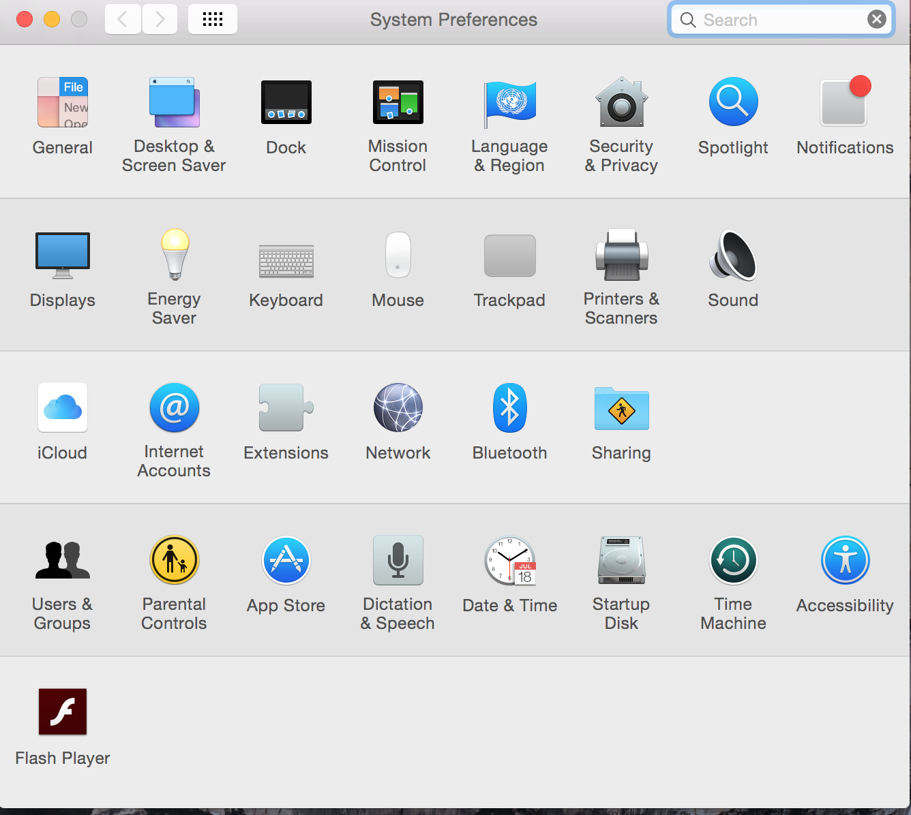
3. Click Change Password

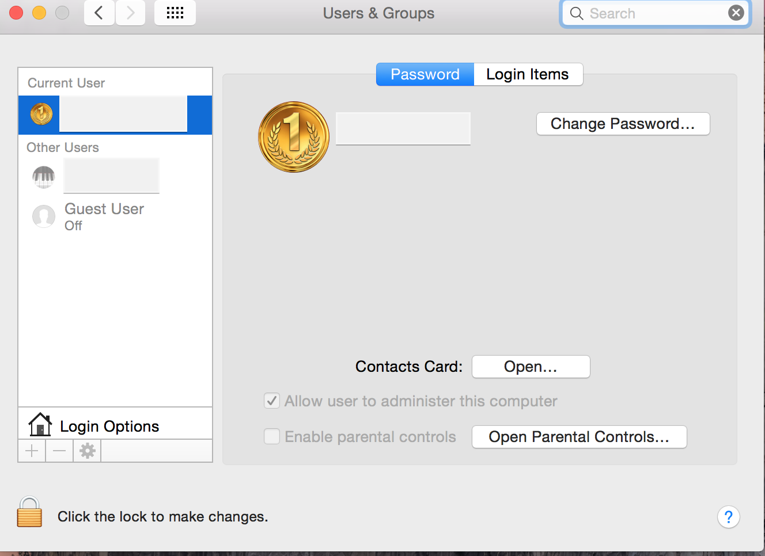

4. Next Screen:

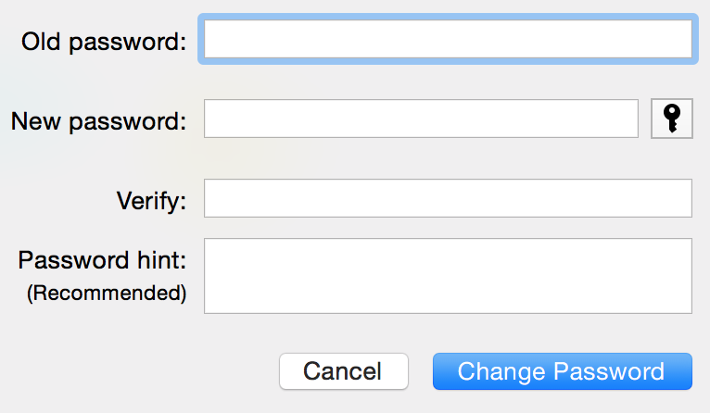
Leave old password field blank
Pick your new password (8 characters include one capital and one digit)
Save password
Restart your computer

